Data analysis

Question 1
A few facts about photometry of asteroids:
• Asteroids are small, irregularly shaped objects of our Solar System that orbit the Sun in approximately elliptical orbits.
- Their brightness observed at a given instant from Earth depend on the surface area illuminated by the Sun and the part of the asteroid which is visible to the observer. Both vary as the asteroid moves.
- The way the sunlight is reflected by the surface of the asteroid depends on its texture and on the angle between the Sun, the asteroid and the observer (phase angle), which varies as the Earth and the asteroid move along their orbits. In particular, asteroids with surfaces covered by fine dust (called regoliths) exhibit a sharp increase in brightness at phase angles φ close to zero (i.e., when they are close to the opposition).
• Since the observed flux of any source decreases with the square of distance, the observed magnitude of an asteroid also depends on its distance from the Sun and from the observer at the time of the observation. Their apparent magnitude m outside the atmosphere is then
m(t) = mr(t)+5log(RD)

where m_{r}(t) is usually called reduced magnitude (meaning the magnitude the asteroid would have if its distances from the Sun and the Earth were reduced both to 1 AU) and depends only on the visible illuminated surface area and on phase angle effects. R and  are, respectivelly, the heliocentric and geocentric distances.
Consider now the following scenario. Light curves of a given asteroid were obtained at three different nights at different points of its orbit, and at each time a photometric standard was observed in the same frame of the asteroid. Table 1 shows the geometric configuration of the asteroid at each night (phase angle φ, in degrees, R and  in AUs), and the calibrated magnitude of the photometric standard star that was observed along with the asteroid. Consider the calibrated magnitude as the final apparent magnitude after all the effects are taken into account.
Tables 2, 3 and 4 contain, for each night, the time interval since the first observation e (in hours) the air mass, the instrumental magnitude of the asteroid and the instrumental magnitude of the star.
Air mass is defined as the dimensionless thickness of the atmosphere along the line of sight, and is equal to 1 when looking to zenith.
1. Plot the star magnitude versus air mass for each set
2. Calculate the extinction coefficient for each night (see Appendix A at the end of the text)
3. Were the observations affected by clouds in any of the nights? Express your answer as: a) Night A, b) Night B, c) Night C, d) None of the nights.

4. Plot the calibrated magnitude versus time for each set of observations of the asteroid (see Appendix B).

5. Determine the rotation period for each night. Consider that the light curve for this asteroid has two minima and two maxima, and that the semi-period is the average of the interval between the two maxima and the two minima.
6. Determine the amplitude of the light curve for each night
7. Plot the calibrated reduced magnitude M_{r} versus phase angle φ (use the mean value of each light curve)
8. Calculate the angular coefficient of the phase curve (the plot of the calibrated reduced magnitude versus the phase angle) considering only the points away from the opposition (See 3rd bullet of facts about photometry of asteroids above)
9. Is there any reason to assume a surface covered by fine dust (regolith)? Answer YES/NO.

Cepheids are very bright variable stars whose mean absolute luminosities are proportional to their pulsation periods. This allows astrophysicists to easily determine their intrinsic luminosities from the variation in their observed, apparent luminosities.

Below is a table with Chepheid data. P₀ is the pulsation period in days and <M_{V}> is the mean absolute visual magnitude.

Cepheid | P₀ (days) | Log₁₀(P₀) | Measured  <M_{V}> | Estimated <M_{V}> | Estimated <M_{V}> - Measured <M_{V}> | (Estimated <M_{V}> - Measured <M_{V}>)²
SU Cas | 1.95 |  | -1.99
V1726 Cyg | 4.24 |  | -3.04
SZ Tau | 4.48 |  | -3.09
CV Mon | 5.38 |  | -3.37
QZ Nor | 5.46 |  | -3.32
α UMi | 5.75 |  | -3.42
V367 Sct | 6.30 |  | -3.58
U Sgr | 6.75 |  | -3.64
DL Cas | 8.00 |  | -3.80
S Nor | 9.75 |  | -3.95
ζ Gem | 10.14 |  | -4.10
X Cyg | 16.41 |  | -4.69
WZ Sgr | 21.83 |  | -5.06
SW Vel | 23.44 |  | -5.09
SV Vul | 44.98 |  | -6.04

QUESTION 1:
Complete the 3rd column of the table with the common (decadic) logarithm of the pulsation period.

QUESTION 2:
Plot all Cepheids in a scatter diagram. Log₁₀(P₀) should be the abscissa and <M_{V}> should be the ordinate.

QUESTION 3:
Fit, by eye, a straight line to the <M_{V}> vs log₁₀(P₀) plot. Deduct the line equation that allows one to obtain the luminosity from the pulsation period.

QUESTION 4:
Let’s estimate the fit standard deviation. For this, fill the 5th column of the table with the estimated <M_{V}> obtained from the equation derived in question 3.
Then fill in the remaining columns.
Obtain the standard deviation of the fit from the following equation:

SD =

Below are two Cepheid light curves.

Cepheid 1:
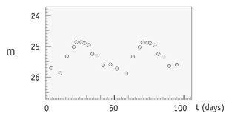
Cepheid 2:
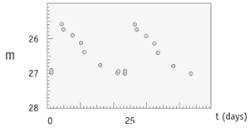

QUESTION 5:
From the light curves, estimate the mean apparent luminosities <m_{V}>.

QUESTION 6:
From the light curves, determine the pulsation periods P₀. Use the equation determined in question 3 along with the standard deviation of question 4 to obtain the Cepheids’ mean absolute luminosities and their errors.

Cepheids are very useful to astronomers as a way to determine the distances to other galaxies. Since these stars are very luminous, they can be observed from very far away. The distance in parsecs to the star can be obtained from its distance modulus:

d(pc) = 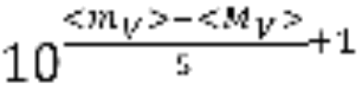

QUESTION 7:
From the data obtained in questions 5 and 6 estimate the distances to the Cepheids.

Table 1

Night | R |  | φ | m_{star}
A | 0.36 | 1.35 | 0.0 | 8.2
B | 1.15 | 2.13 | 8.6 | 8.0
C | 2.70 | 1.89 | 15.6 | 8.1

Table 2: Night A Table 3: Night B

t | Air mass | m_{ast} | m_{star} |  | t | Air mass | m_{ast} | m_{star}
0.00 | 1.28 | 7.44 | 8.67 |  | 0.00 | 1.28 | 11.64 | 8.58
0.44 | 1.18 | 7.38 | 8.62 |  | 0.44 | 1.18 | 11.53 | 8.54
0.89 | 1.11 | 7.34 | 8.59 |  | 0.89 | 1.11 | 11.56 | 8.60
1.33 | 1.06 | 7.28 | 8.58 |  | 1.33 | 1.06 | 11.49 | 8.52
1.77 | 1.02 | 7.32 | 8.58 |  | 1.77 | 1.02 | 11.58 | 8.48
2.21 | 1.00 | 7.33 | 8.56 |  | 2.21 | 1.00 | 11.79 | 8.63
2.66 | 1.00 | 7.33 | 8.56 |  | 2.66 | 1.00 | 11.67 | 8.53
3.10 | 1.01 | 7.30 | 8.56 |  | 3.10 | 1.01 | 11.53 | 8.46
3.54 | 1.03 | 7.27 | 8.58 |  | 3.54 | 1.03 | 11.47 | 8.48
3.99 | 1.07 | 7.27 | 8.58 |  | 3.99 | 1.07 | 11.63 | 8.67
4.43 | 1.13 | 7.31 | 8.61 |  | 4.43 | 1.13 | 11.51 | 8.51
4.87 | 1.21 | 7.37 | 8.63 |  | 4.87 | 1.21 | 11.65 | 8.55
5.31 | 1.32 | 7.42 | 8.67 |  | 5.31 | 1.32 | 11.77 | 8.61
5.76 | 1.48 | 7.49 | 8.73 |  | 5.76 | 1.48 | 11.88 | 8.75
6.20 | 1.71 | 7.59 | 8.81 |  | 6.20 | 1.71 | 11.86 | 8.78
6.64 | 2.06 | 7.69 | 8.92 |  | 6.64 | 2.06 | 12.03 | 9.03
7.09 | 2.62 | 7.87 | 9.14 |  | 7.09 | 2.62 | 12.14 | 9.19
7.53 | 3.67 | 8.21 | 9.49 |  | 7.53 | 3.67 | 12.63 | 9.65

Table 4: Night C Table 5 – Star properties

t | Air mass | m_{ast} | m_{star} |  | Spectral type | Surface temperature (K)
0.00 | 1.28 | 13.24 | 8.38 |  | O | > 30000
0.44 | 1.18 | 13.21 | 8.36 |  | B | 10000 - 30000
0.89 | 1.11 | 13.13 | 8.34 |  | A | 7500 - 10000
1.33 | 1.06 | 13.11 | 8.33 |  | F | 6000 - 7500
1.77 | 1.02 | 13.11 | 8.32 |  | G | 5100 - 6000
2.21 | 1.00 | 13.15 | 8.32 |  | K | 3700 - 5100
2.66 | 1.00 | 13.17 | 8.32 |  | M | <3700
3.10 | 1.01 | 13.17 | 8.32
3.54 | 1.03 | 13.13 | 8.33
3.99 | 1.07 | 13.15 | 8.34
4.43 | 1.13 | 13.14 | 8.34
4.87 | 1.21 | 13.14 | 8.37
5.31 | 1.32 | 13.21 | 8.38
5.76 | 1.48 | 13.30 | 8.43
6.20 | 1.71 | 13.34 | 8.47
6.64 | 2.06 | 13.39 | 8.54
7.09 | 2.62 | 13.44 | 8.65
7.53 | 3.67 | 13.67 | 8.87

Figure 1

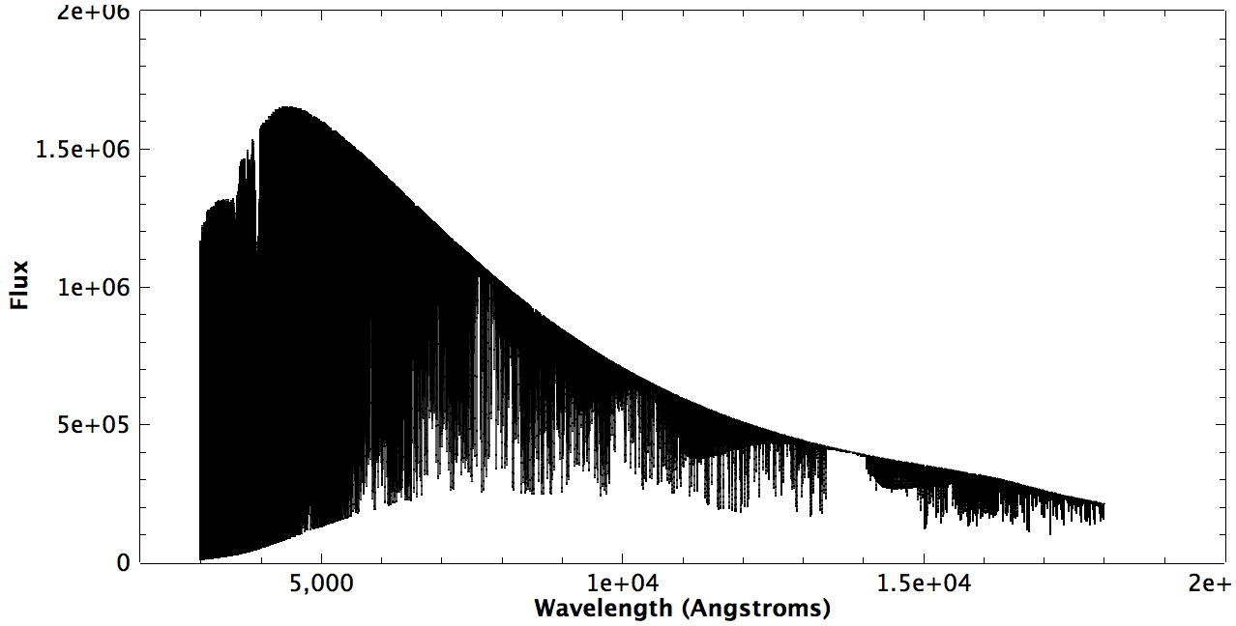

Figure 2

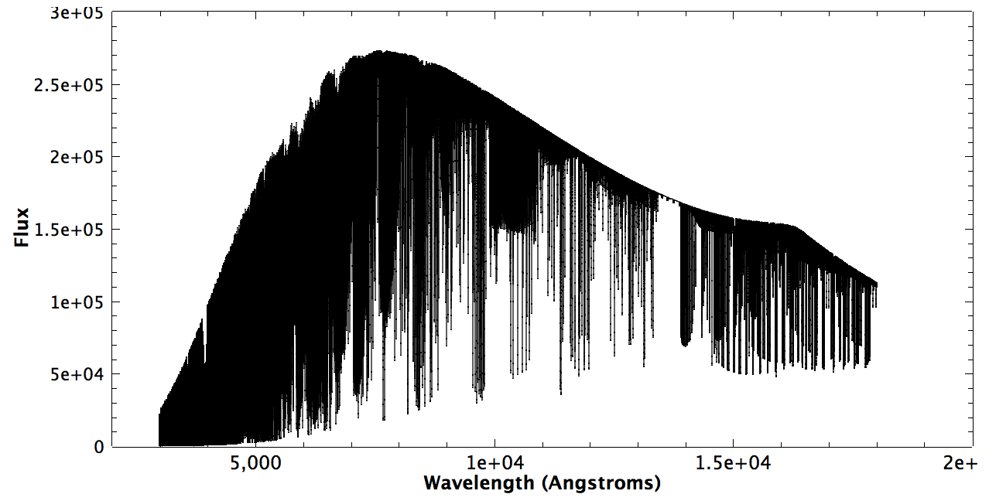

Appendix A: extinction coefficients
The magnitude outside the atmosphere is given by:
M = m  A.X + B
where A is the extinction coefficient and B is the zero point coefficient for the night, X is the airmass of the observation and m is the instrumental magnitude (that is, the magnitude obtained directly from the image)

Appendix B: calibrated differential magnitude
If the standard star is the same frame as the object, the calibrated magnitude of the object can be obtained by:
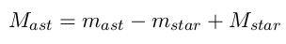

Appendix C: least squares estimation of angular coefficients
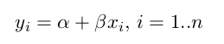
Given straight lines described by
the least squares estimator of β is given by
